Bahria University,

Karachi Campus



LAB EXPERIMENT NO.

**05**

LIST OF TASKS

|  |  |
| --- | --- |
| TASK NO | OBJECTIVE |
| 01 | Use the Customer Call List Data.csv File and perform Data Cleaning Operations on it |

**SUBMITTED ON**

**02/11/2023**

**LAB 05 DATA CLEANING**

**TASK:**

Use the Customer Call List Data.csv File and perform Data Cleaning Operations on it

1. **Load CSV**

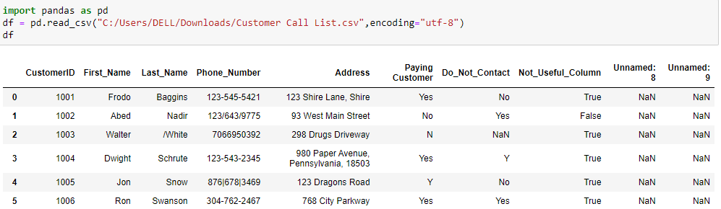

1. **Check For Duplicates**

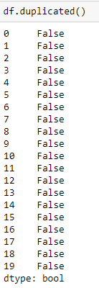

1. **Stripping Unnecessary Characters From Last Name Column**

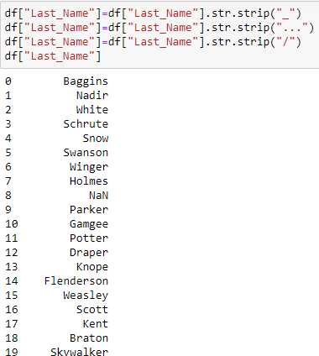

1. **Replacing Unnecessary Characters,NaN,N-a and Using –**

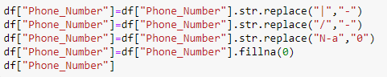

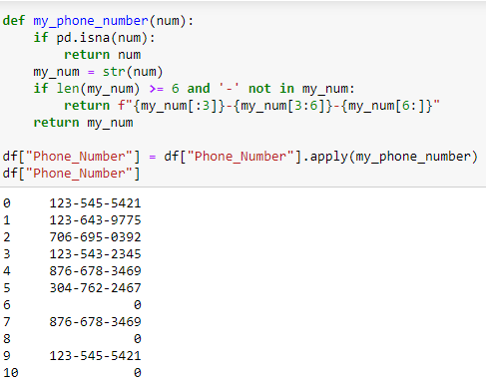

1. **Dropping Unnecessary Columns**



1. **Cleaning Address Column**

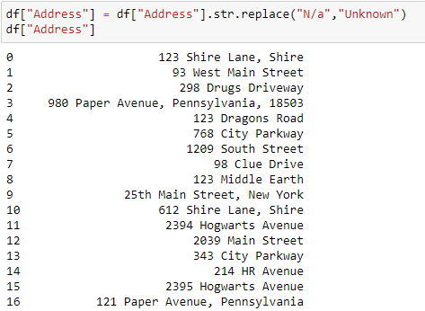

1. **Cleaning Paying Customer Column**

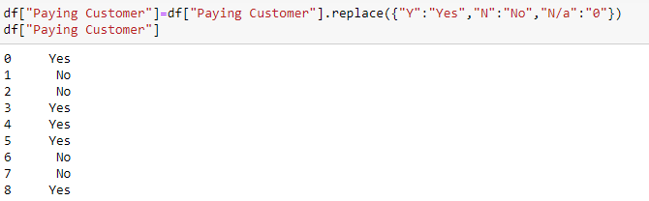

1. **Cleaning Do_Not_Contact Column**

